Enabling industry collaboration

While the majority of blockchain-related activity in insurance to date has focused on internal POC projects, industry players are also coming together to investigate the viability of wider blockchain platforms. One such organization is the EU-based Blockchain Insurance Industry Initiative (B3i). B3i was originally a collaborative effort between major insurers and reinsurers to investigate potential blockchain use cases across the industry, and was incorporated in March of 2018 as [B3i Services AG](https://b3i.tech/about-us.html) with the goal of “[streamlining] the development, testing and commercialisation of blockchain solutions” in insurance.

An excellent collaborative blockchain use case is that of fraud detection and prevention. Criminal activity often exploits insurers' “blind spots,” where fraudulent patterns can only be detected across a wide data set, often across multiple insurers. Legal and competitive challenges have hampered insurers' attempts to share intelligence on fraudulent activity to date; however, development of a blockchain network could provide a way for competitors to safely and securely share data, gain visibility into criminal patterns, and prevent future losses.

On the claims side, blockchain could also transform responses to catastrophic events. Where today insurers, reinsurers and brokers need to manage masses of paperwork and electronic forms created by parties such as claims assessors, lawyers, and salvage experts, a blockchain based claims system would make the process of sharing data faster and more efficient, creating significant operational savings for all parties.

## Proof of concept projects and beyond

There are dozens of potential use cases for blockchain technology within any insurance firm. When investigating blockchain integration, the question quickly transforms from, “How can blockchain help?” to “Which specific use cases offer the greatest long-term value and return on investment?”. To some insurers, blockchain also presents an opportunity to challenge long-standing assumptions and rethink existing insurance business models. While most blockchain activity is still in the proof of concept (POC) stage, we are already seeing some more viable applications being tested in the market.

Early adopters have started to explore use cases which leverage on the intrinsic properties of blockchain to lower operational costs related to transaction processing and improved data accuracy through increased trust between parties. One area already getting a lot of notice is the use of smart contracts, which execute automatically upon achievement of specific contractual criteria. For example, in 2017 AXA launched [fizzy](https://fizzy.axa/en-gb/), an **automated parametric insurance platform for delayed flights**. Fizzy records information on customers' purchased flight delay insurance using a smart contract, and connects to global air traffic databases to monitor flight statuses. If a policyholder experiences a flight delay of two or more hours as reported by airport information, the smart contract triggers the mechanism for payment upon receipt of flight confirmation by the policyholder and Fizzy automatically pays the customer. Not only does this mean that the customer is spared the hassle of filing out claim forms or speaking to a service assistant, but AXA also avoids the need to spend time processing the claim through independent verification of the claims data. At KPMG we have undertaken a similar POC with the following process flows:

<https://home.kpmg/xx/en/home/insights/2018/09/blockchain-in-insurance-fs.html>

Despite the rise of online brokers, many consumers still call insurance brokers by phone to purchase new policies. Policies are often processed on paper contracts, which means claims and payments are error-prone and often require human supervision. Compounding this is the inherent complexity of insurance, which involves consumers, brokers, insurers and reinsurers, as well as insurance’s main product — risk.

Each step in this collaborative process represents a potential point of failure in the overall system, where information can be lost, policies misinterpreted, and settlement times lengthened.

Enter blockchain technology, a cryptographically secured form of shared record-keeping.

While blockchain technology has been subject to extreme hype, its true killer applications are likely to be in some of the most antiquated fields out there. And it has the ability to be a transformative force for industries like insurance, which require the coordination and cooperation of many different intermediaries with different incentives.

Of course, getting there will be no mean feat. Insurance companies and startups working with blockchain technology will have to overcome significant regulatory and legal hurdles before we see anything resembling industry-wide disruption. Skeptics point out that there are serious obstacles for blockchain technology in an industry that hasn’t even fully embraced the cloud.

It’s too early to tell whether blockchain technology can overcome the legal and regulatory hurdles to become the default standard across the insurance industry. But the possibilities are endless, and insurance companies and startups alike are exploring insurance applications for the technology at full throttle.

These applications include:

* **Fraud detection & risk prevention:**By moving insurance claims onto an immutable ledger, blockchain technology can help eliminate common sources of fraud in the insurance industry.
* **Property & casualty (P&C) insurance:**A shared ledger and insurance policies executed through smart contracts can bring an order of magnitude improvement in efficiency to property and casualty insurance.
* **Health insurance:**With blockchain technology, medical records can be cryptographically secured and shared between health providers, increasing interoperability in the health insurance ecosystem.
* **Reinsurance:**By securing reinsurance contracts on the blockchain through smart contracts, blockchain technology can simplify the flow of information and payments between insurers and reinsurers.

Read on for a deep dive into how blockchain technology could disrupt the insurance industry.

#### TABLE OF CONTENTS

* [Fraud detection & risk prevention](https://www.cbinsights.com/research/blockchain-insurance-disruption/#fraud)
* [P&C insurance](https://www.cbinsights.com/research/blockchain-insurance-disruption/#property)
* [Health insurance](https://www.cbinsights.com/research/blockchain-insurance-disruption/#health)
* [Reinsurance](https://www.cbinsights.com/research/blockchain-insurance-disruption/#reinsurance)
* [Moving towards a blockchain-powered insurance industry](https://www.cbinsights.com/research/blockchain-insurance-disruption/#conclusion)

### 1. Fraud detection and risk prevention

#### KEY TAKEAWAYS

* + Insurance fraud costs more than $40B a year and is difficult to detect using standard methods.
  + Blockchain’s shared ledger technology can move fraud detection forward by consolidating claims data across insurers.
  + By facilitating better data sharing, blockchain technology can save insurers the expense of paying for public and subscription data to prevent fraud.

#### **FRAUD DETECTION TODAY**

The total cost of insurance fraud (not counting health insurance) in the US is estimated to be more than $40B a year, [according](https://www.fbi.gov/stats-services/publications/insurance-fraud) to the FBI.

This isn’t just a problem for the insurance companies losing money — insurance fraud costs the average US family anywhere between $400 and $700 in the form of increased premiums.

The sheer complexity of the modern insurance industry creates gaps in visibility that can be exploited to perpetrate fraud. Claims are shuffled from insurees to insurers and reinsurers in a slow, paperwork-driven process that has many moving parts. This creates opportunities for criminals to make multiple claims across different insurers for a single loss, or enables brokers to sell insurance policies and pocket the premiums.

#### FRAUD DETECTION USING BLOCKCHAIN TECHNOLOGY

Blockchain technology can enable better coordination between insurers to combat fraud.

On a distributed ledger, insurers could record permanent transactions, with granular access controls to protect data security. Storing claims information on a shared ledger would help insurers collaborate and identify suspicious behavior across the ecosystem.

Today, major insurersinvest in data gathered from the public domain and from private companies in order to better predict and analyze fraudulent activities. Public data can be used to identify patterns of fraudulent behavior from previous transactions, but it’s often inconsistent due to the difficulty of sharing sensitive information between different organizations. Developing industry-wide fraud prevention is crippled by the constraints around sharing personally identifiable information — such as name, address, date of birth, etc.

Introducing blockchain technology to stop fraud would take an enormous level of coordination among insurers, but could be hugely beneficial in the long run.

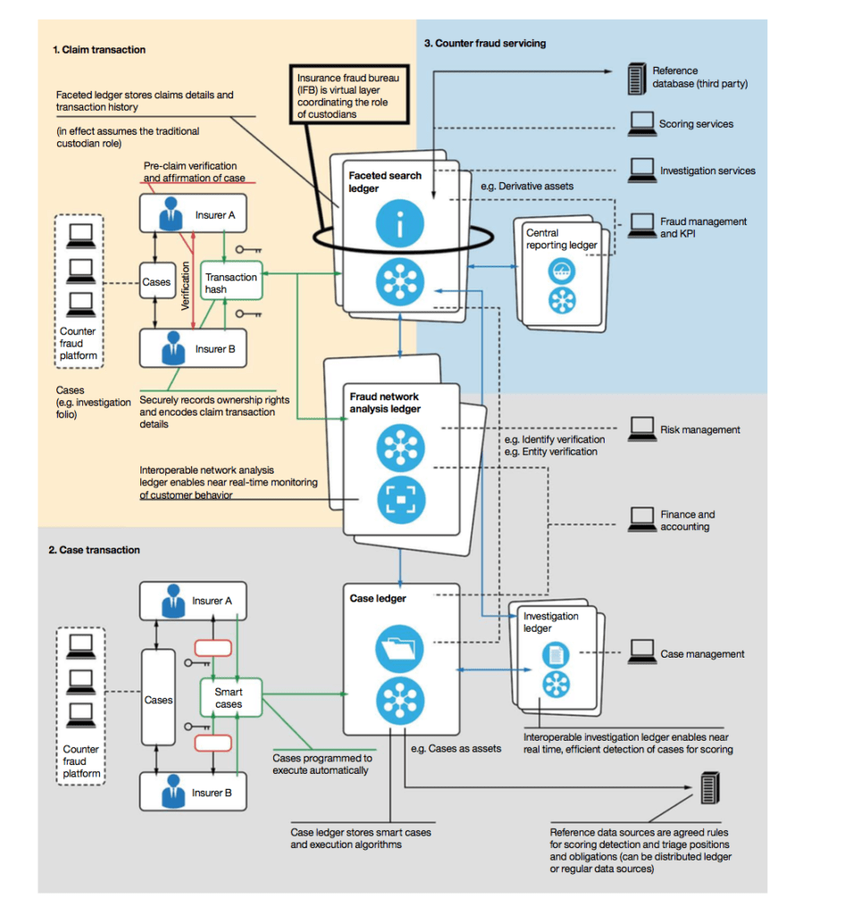

*A proposed counter-fraud blockchain implementation. Source: IBM*

A blockchain-based effort to counter fraud could begin with the sharing of fraudulent claims to help identify patterns of bad behavior. That would give insurers 3 key benefits:

* Eliminating double-booking, or processing multiple claims from the same accident
* Establishing ownership through digital certificates and reducing counterfeiting
* Reducing premium diversion, for example, in the case of unlicensed brokers selling insurance and pocketing premiums

Less fraud in insurance translates directly to higher margins for insurance companies, which can lead to cheaper premiums for consumers.

##### **Blockchain use case: Etherisc**

Blockchain technology startup Etherisc built a blockchain-enabled insurance product that it began testing publicly in October 2017. Its cryptocurrency-based flight delay program allowed passengers to purchase flight insurance using either cryptocurrency or fiat money such as USD and Euros, then receive payouts automatically after a qualifying event. Other products in development include hurricane insurance, crypto wallet insurance, and crop insurance.

Etherisc’s products are powered by smart contracts. A contract is a paper agreement between two or more parties that is enforceable by law; a smart contract is an agreement between two or more parties that lives on a blockchain and is enforceable by code.

The Etherisc smart contract can independently verify claims by using multiple “oracles,” or data sources. For example, when processing a crop insurance claim, Etherisc might compare satellite images, weather station data, and drone videos to photos supplied by the insured. This automated scrutiny can detect fraudulent claims before they’re ever subjected to human review.

Etherisc is still in the early stages (at this time, only its flight delay insurance is licensed) but its example indicates a wider use case for blockchain as a fraud prevention tool.

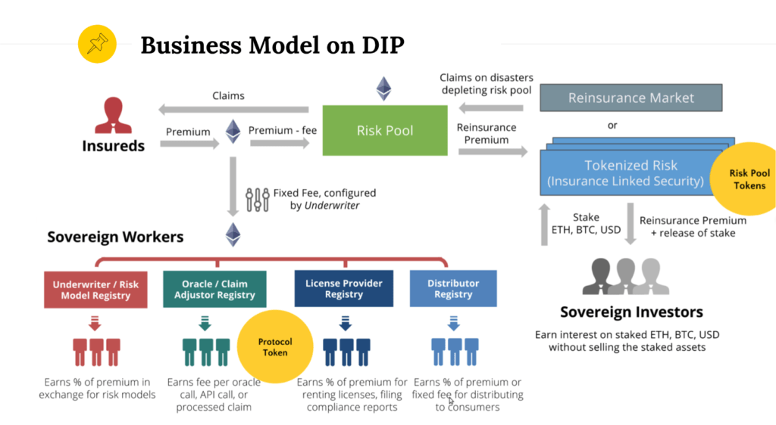

One significant change in the blockchain insurance model is that anyone can invest, and therefore receive a share of the money generated by the insurance. Source:[*Etherisc*](https://blog.etherisc.com/democratizing-insurance-using-blockchain-2cdac647e957)

Insurance fraud is one of the bugbears of the industry, leading to higher premiums and worse coverage for consumers. Combating fraud is one of the most compelling use-cases for blockchain technology, which can provide insurers and insureds a permanent audit trail that can be used to evaluate claims.

But an insurance audit trail isn’t just useful for preventing fraud. It can bring automation and efficiency to the claims processing system, which we’re seeing companies experiment with in the property and casualty insurance space.

Top of Form

### 2. Property and Casualty insurance

#### KEY TAKEAWAYS

* + P&C claims data is scattered across multiple locations controlled by different parties, making claims resolution a challenge.
  + Blockchain technology enables automated real-time data collection and analysis, potentially making some types of P&C claims process up to 3x faster and 5x cheaper than at present.
  + Automated “smart contracts” can greatly speed up claims processing and payouts, saving insurers over $200B a year.

Property and casualty (P&C) insurance is big business, accounting for 48% of all US insurance premiums written in 2017, or a total of $576B.

One of the industry’s biggest challenges is gathering the necessary data to evaluate and process claims. You can think of insurance as a contract that stipulates the premium an insuree pays, as well as the conditions in which the insurer is liable for damages. But “damages” can be subjective, so insurance revolves around verifying that the conditions for each policy are met.

#### P&C INSURANCE TODAY

Processing P&C claims is an error-prone procedure that requires significant manual data entry and coordination between different parties.

Say that you’ve recently gotten into a car accident and the other driver was at fault. To recover losses, you have to submit a claim to your insurance company. Your insurer needs to examine the claim, and then recover the claim for the at-fault driver’s insurance company — which has an entirely different system and process for claims handling.

That’s why property and casualty insurance is such a compelling use-case for blockchain technology, which could transform the way that physical assets are managed, tracked, and insured digitally.

#### P&C INSURANCE ON A BLOCKCHAIN

By allowing policy holders and insurers to track and manage physical assets digitally, blockchain technology can codify business rules and automate claims processing through smart contracts, while providing a permanent audit trail.

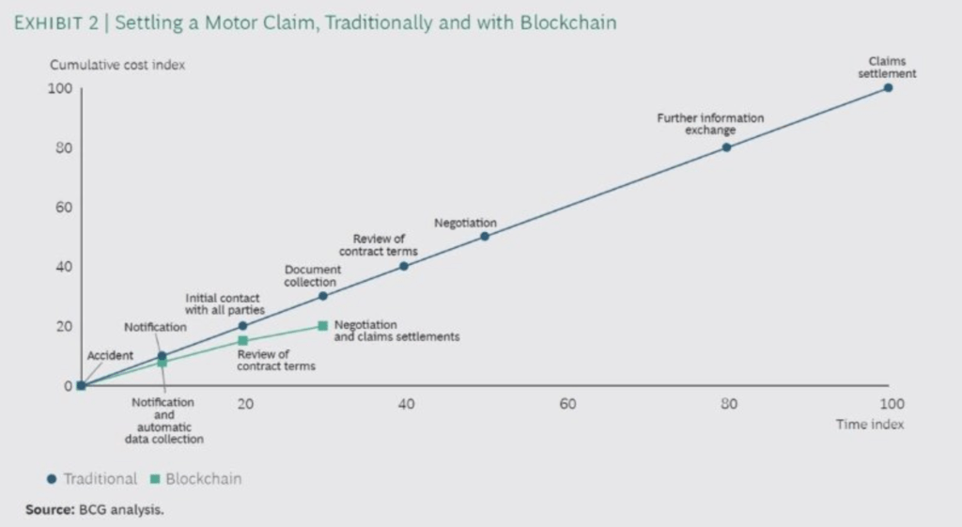

*Blockchain technology could make the process of settling a motor claim as much as 3x faster and 5x less costly. Source: BCG*

Smart contracts using blockchain technology can turn paper contracts into programmable code that helps automate claims processing and calculates liabilities in insurance for all players involved.

For example, when a claim is submitted with an insurer, a smart contract could automatically confirm coverage, and trigger a request for manual review for losses that meet a specific criteria.

Smart contracts could save P&C insurers more than $200B a year in operating costs and lower their operating ratio by anywhere from 5 to 13 percentage points, according to BCG.

For auto insurance, a smart contract could be linked to sensors on a vehicle that automatically alert insurers when a crash occurs. The smart contract can then summon medical teams and towing services, launch the claims process, and inform the insured that help is on the way. As new information such as police reports and crash photos comes in, the smart contract can append them to the claim, facilitating a much faster payout process with minimal human intervention.

<https://www.cbinsights.com/research/blockchain-insurance-disruption/>

### **Claims Processing in Vehicle Insurance**

Here are the steps that can be used by the participants on the blockchain network.

The participants in this scenario are limited to the Industry Regulatory Body, Insured, Insurer, Police Station and Hospital.

The claim submitted here is for vehicular damages and bodily injury due to an accident

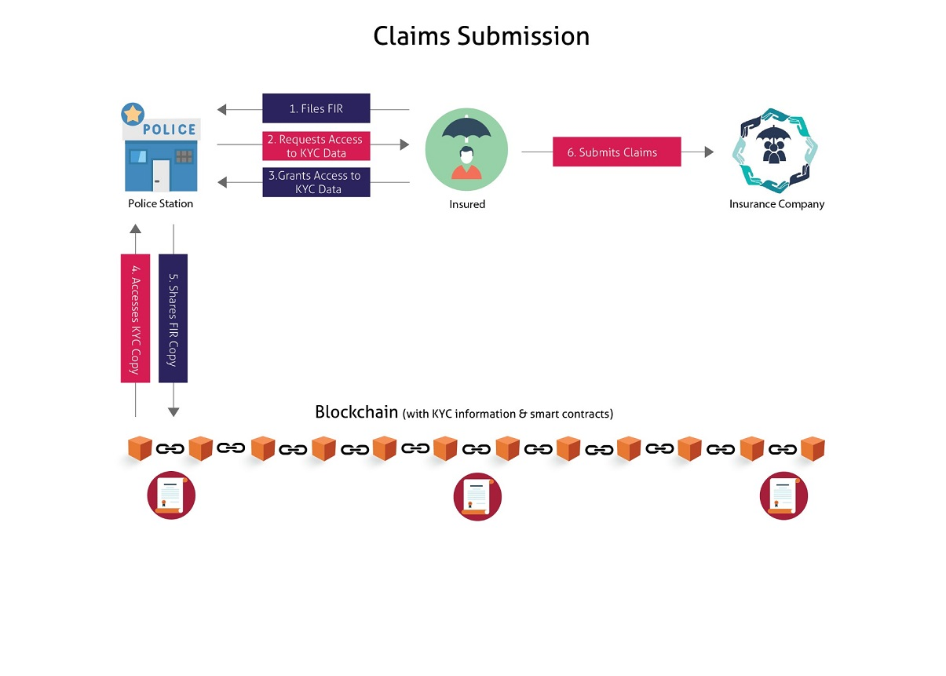

Figure 2: Diagram explaining the common steps in vehicle insurance claim

1. The Insured files the First Information Report (FIR) at the local police station and submits evidence [registration number and photos of his or her vehicle as well as the other vehicle(s) involved, contact details of witnesses and so on].
2. The Police Station requests access to the Insured’s KYC data on the blockchain. A similar request for access will be submitted to the owner or driver of other vehicle(s) involved.
3. Insured provides access to the relevant KYC data. The owner or driver of other vehicle(s) involved also follows a similar process.
4. A copy of the relevant KYC data is made available to the Police Station.
5. Once the FIR is filed by the Police Station in its online system, a copy of the FIR is shared with the Insured’s KYC blockchain. A copy of the same FIR is made available to the owner or driver of other vehicle(s) involved.
6. The Insured approaches the Insurer for submitting claims via an [AI chatbot](https://www.mindtree.com/blog/how-artificial-intelligence-re-inventing-insurance-industry) interface to submit evidence, photos and answers to questions. If the Insured has sustained bodily injuries during the accident, the Insurer will need to be informed of this.

### **Vehicle Damage**

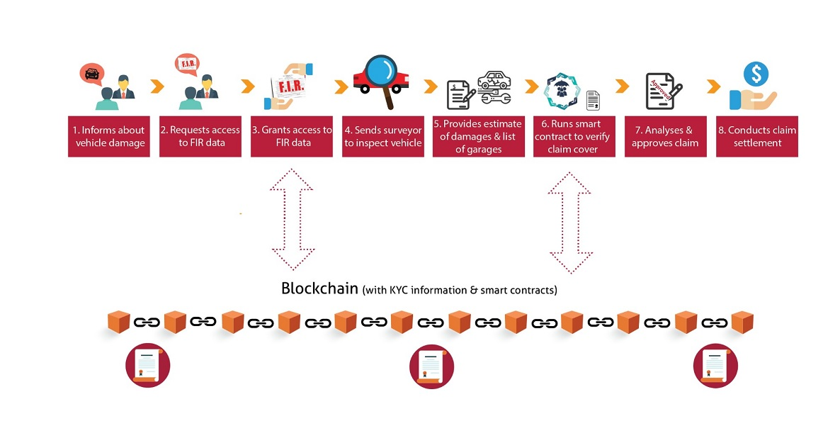

Figure 3: Diagram explaining the flow of events for claim related to vehicle damage.

1. At the time of submitting claims, the Insured informs Insurer about vehicle damage due to the accident.
2. The Insurer requests access to the Insured’s FIR data residing on the blockchain.
3. Insured provides access to the relevant FIR data. A copy of the relevant FIR data is made available to the Insurer.
4. The Insurer sends a surveyor to inspect the vehicle and provides an estimate of the damage.
5. The Insurer also provides a list of its approved garages that can address the repairs.
6. The Insurer then runs a smart contract to verify whether the submitted claims are covered in the policy and calculates a claim amount.
7. The Underwriter reviews and approves the claims and the claims transaction and related details are updated on the blockchain.
8. If the Insured selects a garage from this list, the claim amount will be transferred directly to the garage (cashless claim).
9. If the Insured selects an external garage (that is not present on the Insurer’s list), the claim amount will be reimbursed in the Insured’s bank account.

<https://www.mindtree.com/blog/blockchain-life-and-vehicle-insurance>